**Colour Turf War**

**Instructions:**

1. Compile and run the C program with **CPUlator**: <https://cpulator.01xz.net/?sys=arm-de1soc>, or the **Intel FPGA Monitor Program** on a physical DE1-SoC board.
2. 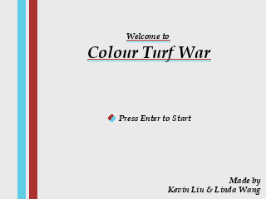Start the game by pressing **enter** at the home screen.
3. Two players compete for more area occupied by their colour on a **22 x 22** gameboard.



1. **Blue Player** uses **WASD keys** on the keyboard to control their avatar’s movement, and **Red Player** uses **arrow keys** to control their avatar’s movement.



1. Both players leave behind a trail of “residues” when they move. Each tile of residue remaining on the gameboard grants its player **1 point**. When a player’s residues get covered up by the opposing colour, the player’s points decreases as well.



1. Look out for splash bombs that generate at random locations later into the game. Detonating splash bombs by passing through them create giant explosions of residues.



1. The first player that obtains a score of **250 points** wins the game!

**Attribution Table**

|  |  |  |
| --- | --- | --- |
| **Tasks/Contributors** | **Kevin Liu** | **Linda Wang** |
| **Game Art Assets & Textures** | Designed all arts using Aseprite. All arts used for the game are original. | N/A |
| **Drawing Arts & Texts on Screen** | Coded, optimized, commented | Coded |
| **Starting Menu/Pre-Game Features** | Coded, optimized, commented | Coded, optimized, commented |
| **Acquiring PS/2 User Inputs** | Researched, coded, commented | Researched |
| **Basic Game Logics**  **-Player Movements** | Coded, optimized, commented | Coded, optimized, commented |
| **Basic Game Logics**  **-Residue Mechanic** | Coded, optimized, commented | Optimized |
| **Basic Game Logics**  **-Scoring & Winner Determination** | Coded, optimized, iterated, commented | Coded, optimized, commented |
| **Extra Game Feature**  **-Splash Bomb Mechanic** | Coded, optimized, iterated, commented | Coded, optimized, commented |
| **Project Instructions & Information** | Written. revised | N/A |